What to bring to a Spring/Fall Tent Campout
BOY SCOUT TROOP 315

Be prepared for cold and wetness. Spring or Fall can be unpredictable. The easiest way to stay warm is to dress in layers and stay dry. Dressing in layers allows the scout to regulate heat by taking off and putting on various layers. Wetness, including sweating will lead to a cooling down of the body. This is desirable in the heat, but more troublesome in the cooler temperatures.
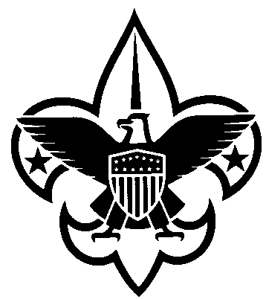
Wear:
• Layers: Jeans and shirt (tee shirt and sweat shirt)
• socks - wool best, acrylics next best, cotton least preferred.
• Heavy jacket or Coat
• Hat
• gloves (if not cold have these in pack, just in case)
• Poncho or raincoat (if not raining - pack it on top of gear in backpack or duffel bag).
• Hiking boots. This is a must.
• Watch (optional, but recommended)

Sleeping bag in water resistant bag
• extra blanket for cool temp (optional)
• insulating foam pad (Closed cell foam).
• sheet for warm weather (optional, but a must in summer)

Backpack or duffel bag for camping gear.
• Jogging suit or other sleeping clothes (some boys find sleeping in a hooded sweatshirt adds warmth).
• change of shoes
• 2 long sleeved shirts
• Sweater or sweatshirt
• 2 pairs of pants
• 2 spare T-shirts
• change of underwear
• 3 extra pairs of socks - wool best, acrylics next best, cotton least preferred.

• Eating kit consisting of "unbreakable/boilable" plate, bowl, mug, spoon, knife, fork.
• Canteen or water bottle
• Toilet articles: Soap in plastic box or zip lock bag
• Toothbrush, toothpaste, comb
• Towel, washcloth in plastic bag
• small roll of toilet paper in zip lock bag
• Flashlight with extra batteries
• Scout knife (Only allowed if the Scout has Whittlin' Chip or Totin' Chip rights)
• Scout handbook
• paper, pencil or pen
• Camera
• Emergency/First Aid kit:
2 quarters for phone calls
3-5 bandaids, other misc. first aid, parent's discretion
All drugs (prescription and non-prescription) must be brought to the leaders' attention and permission must be granted the leader to allow the scout to either (1) self-medicate or (2) have the leader give the medicine. This must be in writing.

NO ELECTRONIC GAMES OR RADIOS, NO ELECTRONICS OF ANY KIND.
Scouts are responsible for their own gear.

NO ELECTRONIC GAMES OR RADIOS, NO ELECTRONICS OF ANY KIND.
Scouts are responsible for their own gear.

