WHAT TO BRING TO SUMMER CAMP

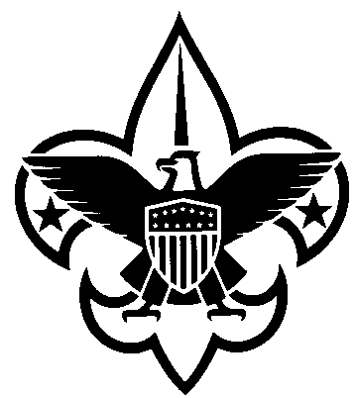This is not meant to be a complete list, just a help for getting ready. Each scout must pack his own belongings.

Bring (1) a duffel bag or a backpack or a trunk to pack in and (2) a sleeping bag, a sheet and pillow. The sheet is for the nights that are too hot to get in the sleeping bag.

All clothing and possessions should be marked with the scout's name and "Troop 315" or "T 315" using a laundry or permanent marker. Mark small and in a place on the clothing not easily seen when wearing. Try to pack in a zippered bag such as a larger sports bag or duffel bag. Some scouts have discovered the luxury of using a trunk or lock box. You should choose the bag or whatever that is the most waterproof. Always put smaller items in separate "zip lock" bags or other "stuff sacks" and then put these smaller bags in your pack or duffel bag. This aids the scout in keeping his stuff neat and dry! You should include a dirty clothes bag.

_____ All extra fees to scoutmaster. (for example leatherwork MB or woodcarving MB fees)
_____ Spending money for fees and souvenirs. The trading post is open daily. The scout will want or
need
MBbooks, t-shirt, candy, slushies, pop, patches, …
_____ Completed medical form (Class 1 & 2 BSA medical form with current picture, signed, shot record,
doctor’s signature).

_____ Scout Outdoor Essentials
_____ Pocketknife
_____ Personal First Aid Kit
_____ Rain Gear - poncho, jacket with hood, hat, ...
_____ Canteen or unbreakable, leakproof water bottle.
_____ Flashlight with fresh batteries (AA size are the most convenient)
_____ Spare bulb and batteries or a backup flashlight (essential on a long camp)
(batteries go fast at summer camp)
_____ Sun protection!!!
_____ Insect Repellent (must work on ticks) in a non- aerosol spray. Buy the pump version or
cream.
Should be unscented to avoid drawing animals to the smell.
_____ Boots (don't forget to waterproof them)
_____ Shoes (tennis shoes, one old pair to get wet and yucky)
_____ Watch (strongly recommended)
_____ Sunglasses (optional)
_____ Notebook and pen(s) or pencil(s) (absolutely essential)
_____ Boy Scout Handbook (absolutely essential, buy a new one if you lost the old)
_____ Merit Badge books if taking merit badges at camp

_____ Sleeping stuff
_____ Sleeping bag with top sheet
_____ Pillow

_____ Cleanup kit - it should contain:
_____ 2 towels, wash cloth (dark in color doesn't show dirt as fast)
_____ Nearly used-up bar of non-perfumed biodegradable soap in a soap container or plastic
bag.
_____ Toothbrush in a tooth brush holder
_____ Toothpaste (sample size)
_____ Floss (makes a good emergency repair string too).
_____ Comb
_____ First Aid kit (packed in its own bag and ready for inspection)
_____ Moleskin for blisters
_____ A few adhesive bandages (band aids)
_____ Very small roll of adhesive tape
_____ Several gauze pads (2-1/2 or 3 inches)
_____ Couple quarters for emergency phone calls
_____ Tylenol or cold medicine if the parent allows self-medication
_____ Prescription medicines (and note to Scoutmaster from parents)

_____ Eating kit or mess kit (everything must be boilable) Only essential if taking cooking Merit Badge.
_____ Spoon, fork, knife
_____ Plate
_____ Bowl

_____ Mug (a second cup is handy too, remember to put your name on it)

_____ Scout uniform(s)
_____ Scout hat with brim for shade
_____ Scout belt
_____ 1-2 uniform shirts, with correct patch placement
_____ 1 pair scout long pants (optional in summer of course)
_____ 1-2 pair scout shorts
_____ 1-2 pair scout socks

_____Other clothing (adjust list for warm or cold) See page 52 Scout Handbook.
_____ Enough other T-shirts for the week (none advertising non-scout like things, e.g., no
"beer/tobacco" companies shirts).
_____ Short sleeved shirt if desired
_____ 6 changes of underwear
_____ Extra shorts
_____ 2 long pants (some activities may require long pants)
_____ Warm jacket (summer weight for cool evenings if we have any)
_____ Work gloves for working around fire or doing a service project
_____ 6 pair socks (including uniform)
_____ Swimming trunks

ABSOLUTELY -
NO ELECTRONIC GAMES OR RADIOS, NO ELECTRONICS OF ANY KIND.
NO VALUABLES

Scouts are responsible for their own gear.

